**Below Knee Prosthesis**

Patient Registration No. ______________

Side Of Amputation : Left Right

Socket Information: Trial Socket Final Socket

Stump Details: Residual limb flexion angle

Foot Size : Shoes Size: Heel Height:

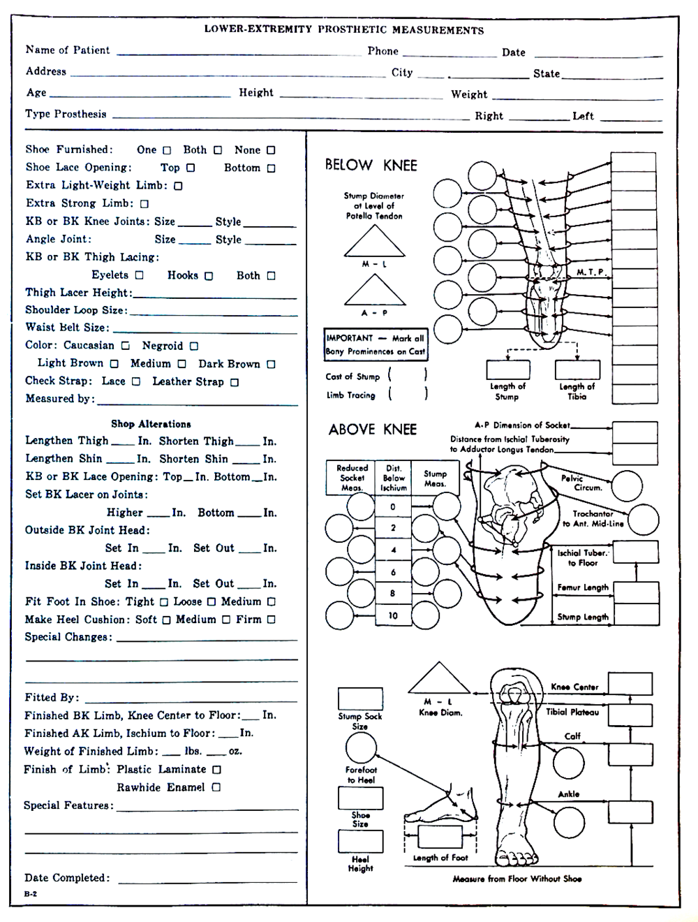

**Other Information :**

|  |
| --- |
|  |
|  |
|  |
|  |
|  |
|  |
|  |
|  |
|  |
|  |
|  |
|  |
|  |
|  |
|  |



**Socket Fabrication**

Trial Socket

Initial Socket Lamination Finish Socket Lamination

Socket With Soft Inner Soft Insert with Buildup

Silicon Socket with Carbon Frame Socket with Padeline Liner

Other :____________________

**Type Of Suspension**

Gel Liner with Pin shuttle Lock Bull Lock

Knee Sleeve Thigh Corset

Seal in Suspension Suction

Variable Pressure (Harmony / Limb logic)

Other :____________________

**Components**

Pylon: 30mm 34mm

Stainless steel Titanium Aluminium

Prosthetic Foot : Foot Name :_________________ Part Code ;_____________________

Tubeclamp Adaptor Part Code :_______________________________________________

Four Prong Adaptor 3 Prong Adaptor Four Hole Adaptor

Pyramid Receiver

**Other Information that may affect prosthetic fitting:**